**Full Stack Development with MERN**

**Project Documentation format**

**1. Introduction**

• **Project Title:** [Your Project Title]

• **Team Members:** List team members and their roles.

**2. Project Overview**

• **Purpose:** Briefly describe the purpose and goals of the project.

• **Features:** Highlight key features and functionalities.

**3. Architecture**

• **Frontend:** Describe the frontend architecture using React.

• **Backend:** Outline the backend architecture using Node.js and Express.js.

• **Database:** Detail the database schema and interactions with MongoDB.

**4. Setup Instructions**

• **Prerequisites:** List software dependencies (e.g., Node.js, MongoDB).

• **Installation:** Step-by-step guide to clone, install dependencies, and set up the environment variables.

**5. Folder Structure**

• **Client:** Describe the structure of the React frontend.

• **Server:** Explain the organization of the Node.js backend.

**6. Running the Application**

• Provide commands to start the frontend and backend servers locally.

o **Frontend:** npm start in the client directory.

o **Backend:** npm start in the server directory.

**7. API Documentation**

• Document all endpoints exposed by the backend.

• Include request methods, parameters, and example responses.

**8. Authentication**

• Explain how authentication and authorization are handled in the project

• Include details about tokens, sessions, or any other methods used.

**9. User Interface**

• Provide screenshots or GIFs showcasing different UI features.

**10. Testing**

• Describe the testing strategy and tools used.

**11. Screenshots or Demo**

• Provide screenshots or a link to a demo to showcase the application.

**12. Known Issues**

• Document any known bugs or issues that users or developers should be aware of.

**13. Future Enhancements**

• Outline potential future features or improvements that could be made to the project.

**DocSpot: Seamless Doctor Appointment Booking Platform**

**1. Introduction**

**Project Title**: DocSpot: Seamless Doctor Appointment Booking Platform

**Team Details:**

**Team ID:** LTVIP2026TMIDS82248

**Team Leader:** Radhamamnohar Kumar Vasamsetti  
**Team Member:** Nagesh Varma Palleti  
**Team Member:** Vineetha Balaka  
**Team Member:** Yajjala Upendra

**2. Project Overview:**

**Purpose of the Project**

The DocSpot project aims to design and develop a full-stack healthcare web application that enables patients to schedule doctor appointments through an online platform. Traditional appointment booking methods often involve manual processes, leading to delays and inefficiencies. DocSpot provides a centralized digital solution that improves accessibility, reduces waiting time, and enhances communication between patients and healthcare providers.

The application is developed using the MERN stack (MongoDB, Express.js, React.js, Node.js) and follows modern software development practices such as RESTful APIs, role-based authentication, and modular architecture.

**Goals of the Project**

1. To create an efficient digital appointment booking system.
2. To implement secure authentication and authorization mechanisms.
3. To provide role-based dashboards for Admin, Doctor, and User.
4. To develop a scalable architecture using cloud database services.
5. To enhance healthcare accessibility through user-friendly design.

**Key Features and Functionalities:**

**Patient Features**

* User Registration and Login with JWT authentication.
* View available doctors and their profiles.
* Book appointments and upload medical documents.
* View appointment history and notifications.

**Doctor Features**

* Manage appointment requests.
* Update profile details.
* Accept or reject appointments.

**Admin Features**

* Approve doctor applications.
* Monitor users and doctors.
* Manage account status and system governance.

**Technical Features**

* RESTful API Architecture.
* MongoDB Atlas Cloud Database.
* Role-Based Access Control.
* Modular MVC Backend Structure.

**3. Architecture:**

**I. Web Application (Frontend Layer):**

The frontend layer of DocSpot is developed using React.js, which provides a component-based architecture. This layer serves as the primary interface where users interact with the system.

**Key frontend responsibilities include:**

* Rendering dashboards for different roles.
* Managing routing using React Router.
* Handling API communication using Axios.
* Providing responsive UI using Material UI, Ant Design, Bootstrap, and MDB React UI Kit.

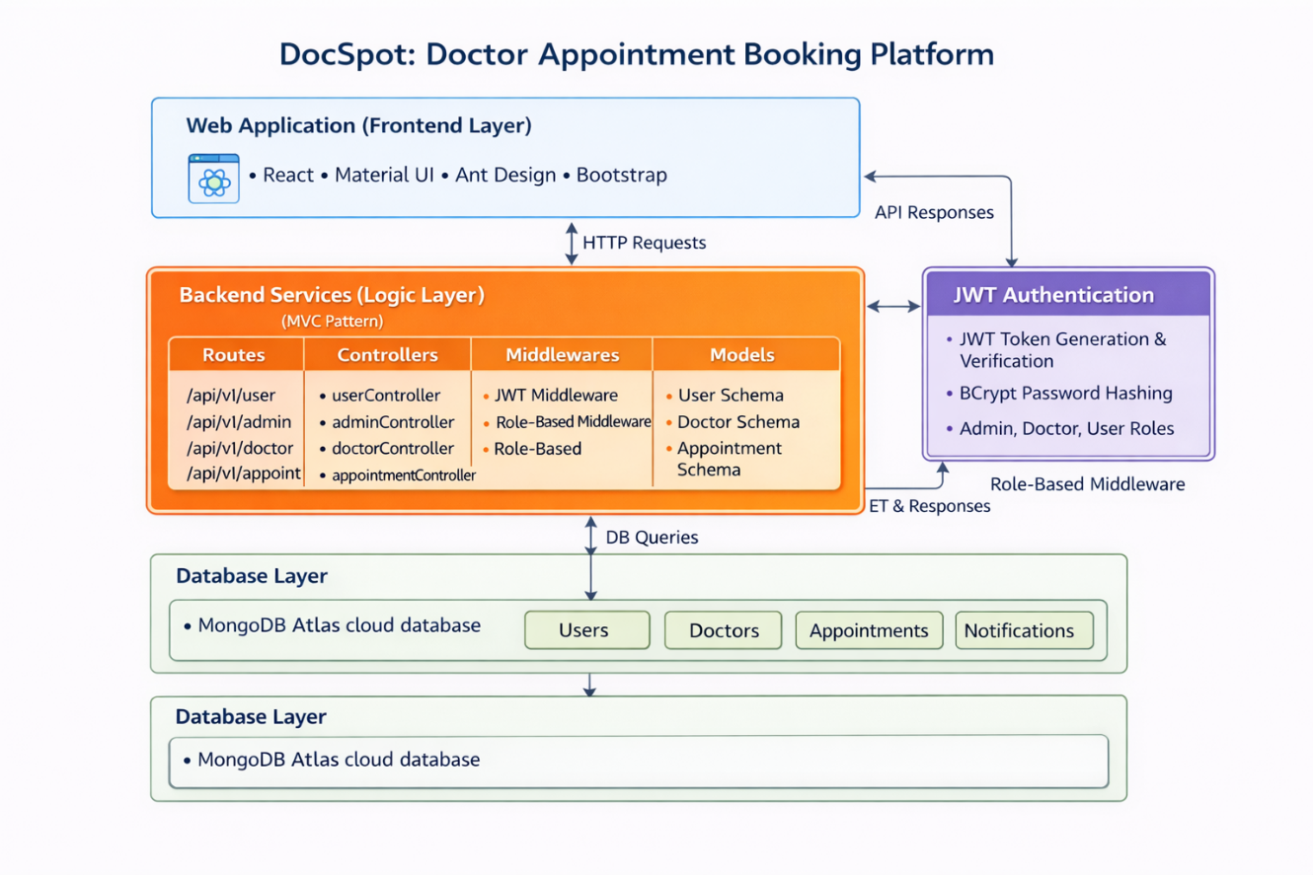

*Fig-1: Main Architecture*

**II. Backend Services (Logic Layer)**

The backend is built using Node.js and Express.js following an MVC architecture.

**Components:**

* **Routes:** Define API endpoints.
* **Controllers:** Contain business logic for appointments, authentication, and admin actions.
* **Middleware:** Handle JWT authentication and role verification.
* **Schemas:** Represent database models using Mongoose.

This layered structure ensures maintainability, scalability, and secure request processing.

**III. Database Layer (MongoDB Atlas)**

The database layer uses MongoDB Atlas, a cloud-hosted NoSQL database.

Collections include:

* Users
* Doctors
* Appointments
* Notifications

MongoDB’s flexible schema allows dynamic data storage and efficient querying.

**4. Setup Instructions:**

**Prerequisites:**

To develop a full-stack Ecommerce App for Furniture Tool using React js, Node.js, Express js and MongoDB, there are several prerequisites you should consider. Here are the key prerequisites for developing such an application:

**Node.js and npm:** Install Node.js, which includes npm (Node Package Manager), on your development machine. Node.js is required to run JavaScript on the server side.

• Download: <https://nodejs.org/en/download/>

• Installation instructions: <https://nodejs.org/en/download/package-manager/>

**MongoDB:** Set up a MongoDB database to store hotel and booking information. Install MongoDB locally or use a cloud-based MongoDB service.

• Download:<https://www.mongodb.com/try/download/community>

• Installation instructions: <https://docs.mongodb.com/manual/installation/>

**Express.js:** Express.js is a web application framework for Node.js. Install Express.js to handle server-side routing, middleware, and API development.

• Installation: Open your command prompt or terminal and run the following

   command: npm install express

**React js:** React is a JavaScript library for building client-side applications.

 And Creating Single Page Web-Application

**Installation Overview**

1. Clone the project repository.
2. Install frontend and backend dependencies.
3. Configure environment variables including database URL and JWT secret key.
4. Run both frontend and backend servers simultaneously.

**Getting Started**

Create React App is an officially supported way to create single-page React applications. It offers a modern build setup with no configuration.

**Quick Start**

npm create vite@latest

cd my-app

npm install

npm run dev

If you've previously installed create-react-app globally via npm install -g create-react-app, we recommend you uninstall the package using npm uninstall -g create-react-app or yarn global remove create-react-app to ensure that npx always uses the latest version.

**Create a new React project:**

• Choose or create a directory where you want to set up your React project.

• Open your terminal or command prompt.

• Navigate to the selected directory using the cd command.

• Create a new React project by running the following command: npx create-react-app your-app-name. Wait for the project to be created:

• This command will generate the basic project structure and install the necessary dependencies

**Navigate into the project directory:**

• After the project creation is complete, navigate into the project directory by running the following command: cd your-app-name

**Start the development server:**

• To launch the development server and see your React app in the browser, run the following command:  npm run dev

• The npm start will compile your app and start the development server.

• Open your web browser and navigate to <https://localhost:5173> to see your React app.

You have successfully set up React on your machine and created a new React project. You can now start building your app by modifying the generated project files in the src directory.

Please note that these instructions provide a basic setup for React. You can explore more advanced configurations and features by referring to the official React documentation: <https://react.dev/>

**HTML, CSS, and JavaScript:** Basic knowledge of HTML for creating the structure of your app, CSS for styling, and JavaScript for client-side interactivity is essential.

**Database Connectivity:** Use a MongoDB driver or an Object-Document Mapping (ODM) library like Mongoose to connect your Node.js server with the MongoDB database and perform CRUD (Create, Read, Update, Delete) operations.

**Front-end Library:** Utilize React to build the user-facing part of the application, including products listings, booking forms, and user interfaces for the admin dashboard.

**Version Control:** Use Git for version control, enabling collaboration and tracking changes throughout the development process. Platforms like GitHub or Bitbucket can host your repository.

**Git:** Download and installation instructions can be found at:<https://git-scm.com/downloads>

**Development Environment**: Choose a code editor or Integrated Development Environment (IDE) that suits your preferences, such as Visual Studio Code.

• Visual Studio Code: Download from <https://code.visualstudio.com/download>

**5. Folder Structure:**

The project is divided into two main modules:

**Client Module:**

Contains React components, routing configurations, and UI-related files.

**Backend Module:**

Includes configuration files, controllers, middleware logic, API routes, database schemas, and server initialization scripts.

This structured organization enhances code readability and promotes modular development.

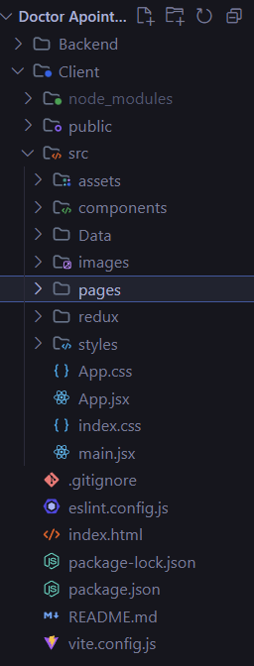

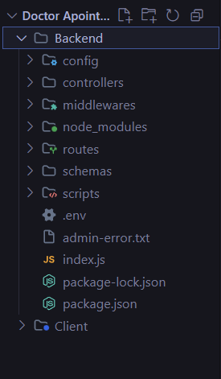

Fig-3: Backend Structure

Fig-2: Client Structure

**Frontend (React Client) – Structure**

The frontend of the DocSpot application is developed using React.js and follows a modular component-based architecture that promotes reusability and maintainability. The client side is responsible for rendering user interfaces, managing user interactions, and communicating with backend APIs through HTTP requests.

The React client is organized into structured folders such as pages, components, redux store, routes, and services. The pages directory contains role-based screens including user dashboard, doctor dashboard, admin panel, authentication pages, and appointment management interfaces. Each page represents a functional module that interacts with backend services.

Reusable UI elements such as navigation bars, loaders, protected routes, and layout wrappers are stored within the components folder. These shared components ensure consistent UI design across different modules of the application.

Global application state is managed using Redux Toolkit, which allows centralized data handling and efficient state synchronization across components. React Hooks such as useState, useEffect, and useSelector are used to manage dynamic rendering, lifecycle events, and API responses.

**Backend (Node.js Server) – Structure:**

The backend of DocSpot is built using Node.js and Express.js following a structured MVC (Model-View-Controller) architecture. This design pattern separates business logic, routing, and database models into independent layers, improving scalability and maintainability of the application.

The backend directory is organized into folders such as config, controllers, middlewares, routes, schemas, and scripts.

The schemas folder defines MongoDB data models using Mongoose. It includes schema definitions for Users, Doctors, Appointments, and Notifications, which represent the core entities of the system. These schemas enforce data structure and enable efficient database interactions.

The routes folder manages API endpoint definitions. Each route file corresponds to a specific module such as userRoutes, doctorRoutes, adminRoutes, and appointmentRoutes. Routes receive incoming HTTP requests and delegate processing to appropriate controllers.

Controllers contain the main business logic of the application. They handle user authentication, appointment booking workflows, doctor approval processes, profile updates, and notification management. Controllers act as an intermediary between routes and database models, ensuring modular design.

The middlewares folder contains authentication and authorization logic. JWT middleware verifies user identity, while role-based middleware restricts access to specific APIs based on user roles such as admin, doctor, or patient. Bcrypt hashing is used to securely store passwords within the database.

The config folder manages database connection settings and environment configurations, enabling secure integration with MongoDB Atlas cloud database.

RESTful API principles are followed throughout the backend, allowing standardized communication between frontend and server. Express.js handles request routing, middleware execution, and response management, ensuring efficient server performance.

This backend architecture enhances security, improves maintainability, and allows future scalability such as microservices integration or cloud deployment.

**Database (MongoDB Atlas) – Structure:**

The DocSpot platform uses MongoDB Atlas as a cloud-based NoSQL database system. MongoDB stores data in flexible JSON-like documents, allowing dynamic schema updates and efficient scalability.

The database consists of multiple collections:

* Users Collection stores patient and admin account details, authentication credentials, and notification data.
* Doctors Collection maintains doctor profile information, specialization, availability timings, and approval status.
* Appointments Collection records booking details, appointment status, uploaded documents, and scheduling information.
* Notifications Collection manages system alerts and communication between users and administrators.

**6. Running the Application:**

To run the application successfully without any errors, we need to run the both backend and frontend at the same time, both should be in the running state simultaneously. To run these both, we need the commands, the commands are:

**For Backend:** First navigate into the folder using the command

**“cd folder name(backend) “**

Next, run the command

**“npm start “.**

**For Frontend:** First navigate into the folder using the command

**“cd folder name(frontend) “**

Next, run the command

“npm run dev “

**7. API Documentation:**

The DocSpot backend exposes multiple RESTful API endpoints that handle authentication, doctor management, appointment booking, notifications, and administrative control. All APIs follow standard HTTP methods such as GET and POST, and responses are returned in JSON format.

Protected routes require JWT authentication middleware to verify user identity and enforce role-based authorization.

**1. Authentication & User APIs**

**1.1 Register User**

**Endpoint:**  
POST /api/v1/user/register

**Description:**  
Creates a new user account in the system.

**Request Body:**

{

"name": "John Doe",

"email": "john@gmail.com",

"password": "123456"

}

**Response:**

{

"message": "User registered successfully"

}

**1.2 Login User**

**Endpoint:**  
POST /api/v1/user/login

**Description:**  
Authenticates user credentials and generates a JWT token.

**Request Body:**

{

"email": "john@gmail.com",

"password": "123456"

}

**Response:**

{

"success": true,

"token": "jwt_token_here",

"user": {

"_id": "12345",

"email": "john@gmail.com"

}

}

**1.3 Get User Data (Protected)**

**Endpoint:**  
POST /api/v1/user/getUserData

**Description:**  
Returns authenticated user profile details.

**Authorization Required:** JWT Token

**1.4 Apply as Doctor**

**Endpoint:**  
POST /api/v1/user/apply-doctor

**Description:**  
Allows a user to submit a doctor application.

**1.5 Notifications APIs**

**Get All Notifications**

POST /api/v1/user/get-all-notification

**Delete All Notifications**

POST /api/v1/user/delete-all-notification

**Description:**  
Fetches or clears user notification history.

**2. Doctor APIs**

**2.1 Get Doctor Info**

**Endpoint:**  
POST /api/v1/doctor/getDoctorInfo

**Description:**  
Fetches profile details of logged-in doctor.

**2.2 Update Doctor Profile**

**Endpoint:**  
POST /api/v1/doctor/updateProfile

**Description:**  
Updates doctor profile details such as specialization, address, and timings.

**2.3 Get Doctor By ID**

**Endpoint:**  
POST /api/v1/doctor/getDoctorById

**Description:**  
Returns doctor information using unique ID.

**3. Appointment APIs**

**3.1 Book Appointment**

**Endpoint:**  
POST /api/v1/appointment/book-appointment

**Description:**  
Creates a new appointment request between patient and doctor.

**Request Body:**

{

"doctorId": "doc123",

"date": "2025-02-10",

"time": "10:00 AM"

}

**Response:**

{

"message": "Appointment booked successfully"

}

**3.2 Check Doctor Availability**

**Endpoint:**  
POST /api/v1/appointment/check-availability

**Description:**  
Checks available time slots before booking.

**3.3 Get User Appointments**

**Endpoint:**  
GET /api/v1/appointment/user-appointments

**Description:**  
Returns appointment history for logged-in patient.

**3.4 Get Doctor Appointments**

**Endpoint:**  
GET /api/v1/appointment/doctor-appointments

**Description:**  
Returns appointment list for doctor dashboard.

**3.5 Update Appointment Status**

**Endpoint:**  
POST /api/v1/appointment/update-status

**Description:**  
Allows doctor to accept or reject appointment requests.

**4. Admin APIs**

**4.1 Get All Users**

**Endpoint:**  
GET /api/v1/admin/getAllUsers

**Description:**  
Fetches all registered users for administrative monitoring.

**4.2 Get All Doctors**

**Endpoint:**  
GET /api/v1/admin/getAllDoctors

**Description:**  
Returns doctor list including approval status.

**4.3 Change Doctor Account Status**

**Endpoint:**  
POST /api/v1/admin/changeAccountStatus

**Description:**  
Admin approves or rejects doctor applications.

**4.4 Change User Status**

**Endpoint:**  
POST /api/v1/admin/change-user-status

**Description:**  
Updates user account status within the system.

**Authentication Requirement**

All protected endpoints require a valid JWT token in request headers:

Authorization: Bearer <token>

JWT middleware verifies identity and enforces role-based access for Admin, Doctor, and User dashboards.

**8. Authentication:**

**Authentication and Authorization in DocSpot**

The DocSpot application implements a secure authentication and authorization mechanism using JSON Web Tokens (JWT) along with role-based access control. The system ensures that only authenticated users can access protected resources such as appointment booking, doctor dashboards, and administrative controls.

Authentication verifies the identity of users, while authorization determines the level of access based on user roles such as **Admin**, **Doctor**, and **User (Patient)**. This layered security approach protects sensitive healthcare information and prevents unauthorized actions within the platform.

**Authentication Process**

Authentication in DocSpot follows a token-based architecture. When a user logs in using valid credentials, the backend server verifies the user’s email and password stored in the MongoDB Atlas database. Passwords are encrypted using bcrypt hashing to ensure secure storage.

After successful verification, the server generates a JSON Web Token (JWT) that includes essential user information such as the user ID and role. This token is digitally signed using a secret key and returned to the frontend application.

The frontend stores the token securely and attaches it to future API requests that require authentication.

Example header format:

Authorization: Bearer <JWT_Token>

Before processing any protected request, the backend authentication middleware validates the token to ensure it is legitimate and has not expired.

**JWT (JSON Web Token) Usage**

The JWT used in DocSpot contains encoded payload information including:

* User ID
* User Role (admin, doctor, user)
* Token expiration timestamp

Using JWT enables:

* Stateless authentication without maintaining server sessions.
* Secure request verification without repeated database queries.
* Efficient communication between frontend and backend services.

Each protected API endpoint uses authentication middleware that performs the following steps:

1. Extracts the token from request headers.
2. Verifies the token using a secret key.
3. Decodes the payload data.
4. Attaches authenticated user information to the request object.

If the token is invalid, missing, or expired, the server denies access and returns an unauthorized response.

**Authorization (Role-Based Access Control)**

DocSpot implements Role-Based Access Control (RBAC) to restrict access to sensitive operations based on user roles.

Every user account contains a role field that determines permissions:

* **User (Patient):** Can browse doctors, book appointments, and manage personal bookings.
* **Doctor:** Can manage appointment requests, update profiles, and review schedules.
* **Admin:** Can approve doctor applications, monitor users, and control system operations.

Authorization middleware checks the role of the authenticated user before allowing access to certain routes.

Examples include:

* Only Admin users can approve doctor accounts or manage system users.
* Only Doctors can update appointment status.
* Only authenticated users can access appointment booking features.

If a user attempts to access a restricted route without proper permissions, the system returns an authorization error.

**Session Handling**

The DocSpot platform uses stateless authentication through JWT tokens instead of traditional server-side sessions. This design improves scalability and performance by eliminating the need to store session data on the server.

Because each request carries authentication information within the token, the backend can validate requests independently without maintaining session state.

**Security Measures Implemented**

Several security practices are implemented to protect the system:

* Passwords are hashed using bcrypt before storing in MongoDB Atlas.
* JWT tokens are signed with a secure secret key.
* Protected routes validate tokens through authentication middleware.
* Role-based authorization prevents unauthorized access to sensitive endpoints.
* Token expiration mechanisms automatically invalidate inactive sessions.

These security measures ensure that DocSpot maintains data confidentiality, integrity, and controlled access throughout the application lifecycle.

**9. User Interface:**

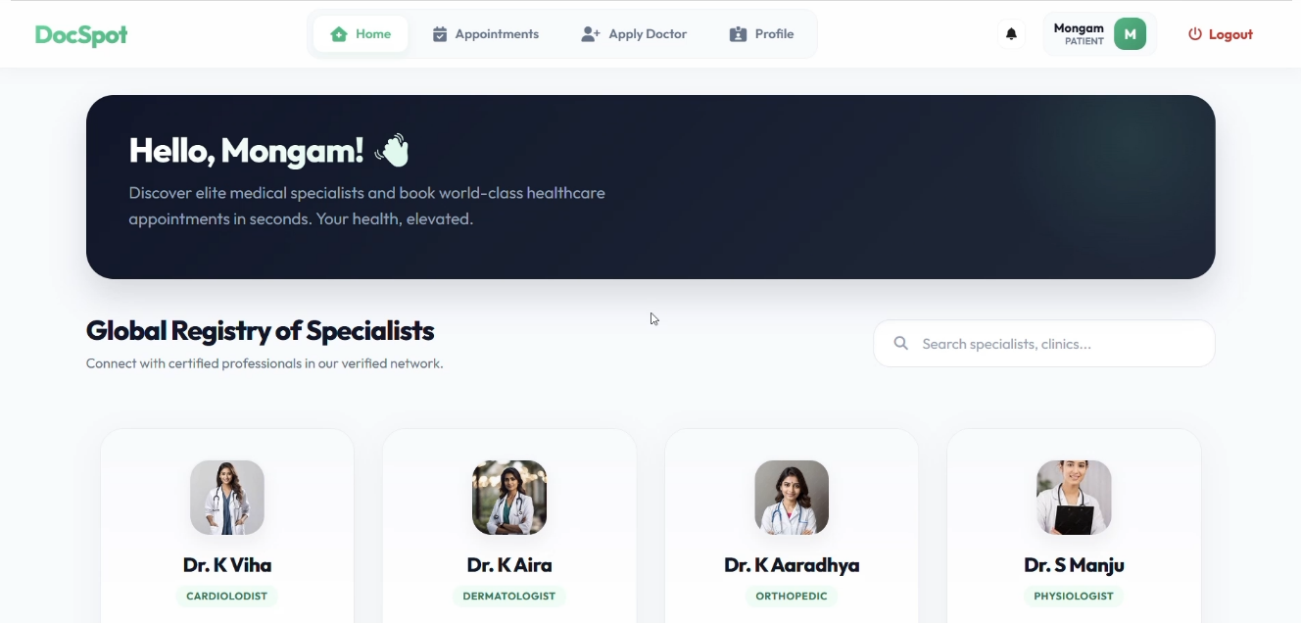

*Fig-4: User Dashboard*

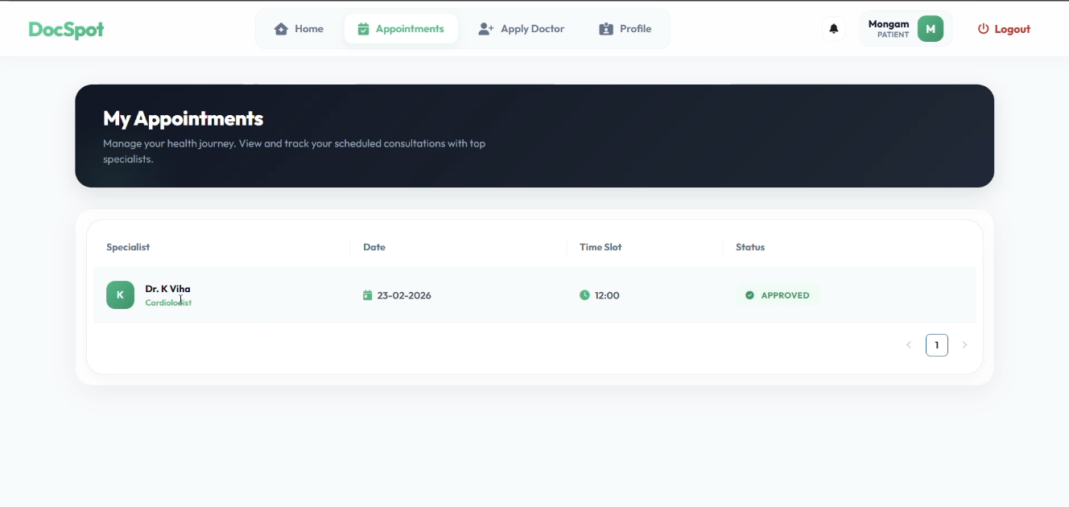

*Fig-4: Appointment History*

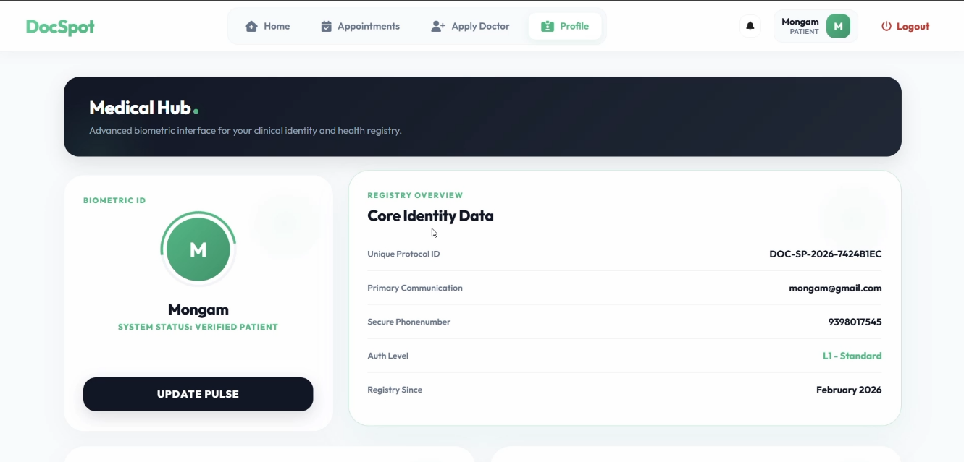

*Fig-5: User Profile*

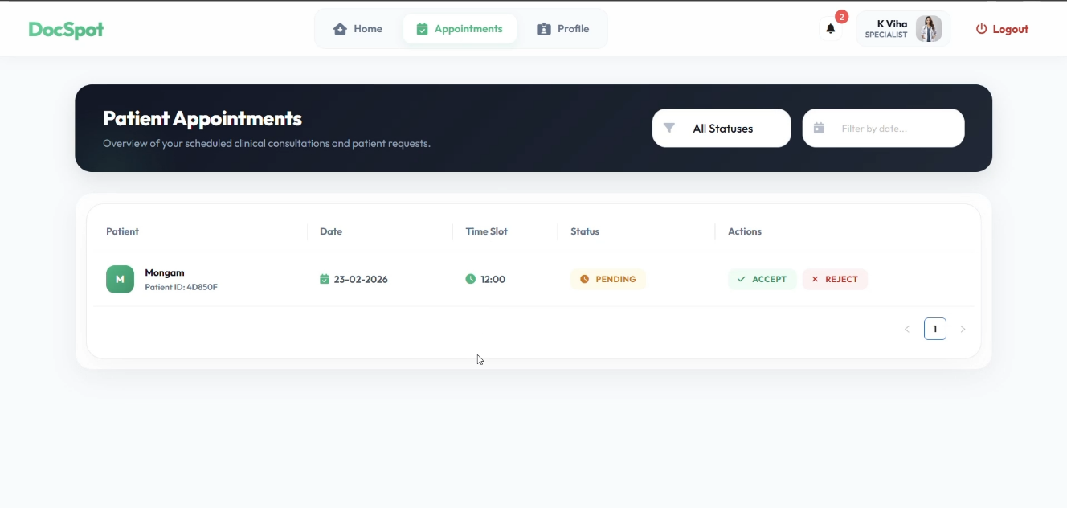

*Figure-5: Doctor Dashboard*

**10. Testing**

**Testing Strategy and Tools Used**

Testing in the ShopSmart project was performed to ensure that the application functions correctly, securely, and efficiently across both frontend and backend components. The testing strategy included manual testing, functional testing, API testing, and validation testing.

**1. Manual Testing**

Manual testing was performed throughout development to verify the correctness of features. Each module, such as authentication, product management, cart operations, and order processing, was tested individually. Test cases were created to check valid inputs, invalid inputs, and edge cases.

**Examples**:

* Testing login with correct and incorrect credentials.
* Checking product search and category filtering.
* Verifying order status updates by admin.
* Ensuring cart updates correctly when items are added or removed.

**2. Functional Testing:**

Functional testing was conducted to ensure that all system functionalities behave according to the requirements. Each feature was tested from a user perspective to confirm that expected outputs were generated for given inputs.

Modules tested include:

* User Registration and Login
* Product CRUD operations
* Cart management
* Checkout and order placement
* Admin dashboard controls
* PDF report generation

**3. API Testing**

Backend APIs were tested using tools such as:

* Postman (for testing REST API endpoints)
* Browser developer tools (Network tab)

Each API endpoint was tested with:

* Valid request data
* Missing fields
* Unauthorized access attempts
* Invalid tokens

This ensured proper error handling and secure API behavior.

**4. Authentication and Authorization Testing**

JWT token verification was tested by:

* Accessing protected routes without a token.
* Using expired or invalid tokens.
* Attempting admin operations with normal user accounts.

The system correctly restricted unauthorized access, confirming proper role-based control.

**5. UI Testing**

Frontend UI testing was performed to ensure:

* Proper rendering of components.
* Responsive layout behavior.
* Correct display of product images and stock status.
* Real-time search suggestions.
* Error message display for failed operations.

**6. Error Handling Testing**

The system was tested for:

* Server errors
* Database connection failures
* Invalid inputs
* Network interruptions

Proper error messages were displayed to the user without crashing the application.

**Tools Used for Testing**

* Postman – for API endpoint testing
* Browser Developer Tools – for debugging frontend
* MongoDB Compass – for verifying database records
* Console Logging – for debugging application flow

**11. Screenshots or Demo:**

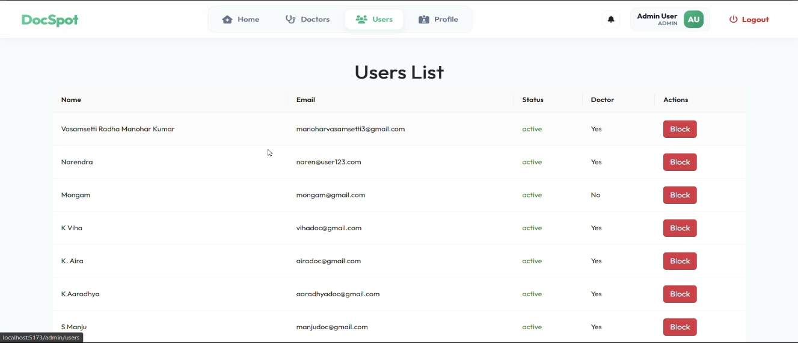

*Figure-6: Admin Dashboard (Users List)*

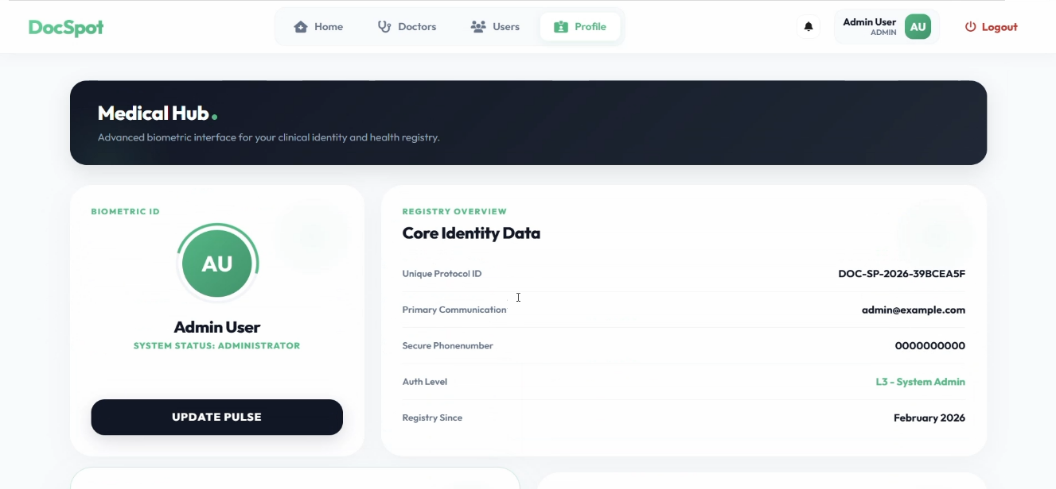

*Figure-7: Admin Profile Page*

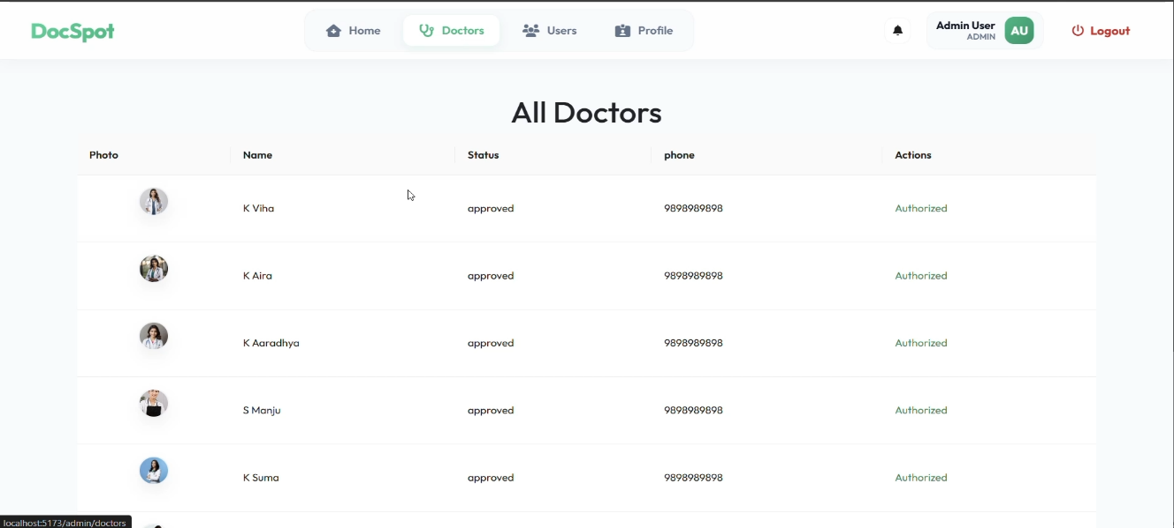

*Figure-8: Admin Dashboard (Doctors List)*

**12. Known Issues:**

Although the DocSpot application successfully implements the core functionalities of an online doctor appointment booking platform, there are certain limitations and known issues that may affect usability and scalability.

**1. No Real-Time Appointment Updates**

Currently, appointment status updates are reflected only after page refresh. The system does not include real-time notification mechanisms such as WebSockets or push services.

**Impact:**  
Users may not immediately see updates when a doctor approves or rejects an appointment request.

**2. JWT Token Storage in Local Storage**

Authentication tokens are stored in browser local storage for maintaining login sessions.

**Impact:**  
While suitable for development and academic projects, storing tokens in local storage may expose potential security risks such as XSS attacks in production environments.

**3. Limited Mobile Responsiveness**

The user interface is optimized mainly for desktop usage. Some layouts may not fully adapt to smaller mobile screens.

**Impact:**  
Mobile users may experience minor UI alignment issues.

**4. File Upload Performance**

Uploading medical documents during appointment booking depends on network speed and file size.

**Impact:**  
Large files may take longer to upload, affecting user experience.

**5. No Payment Integration**

The current system focuses only on appointment scheduling and does not include online payment or billing features.

**Impact:**  
The application is suitable for demonstration and learning purposes but requires payment gateway integration for real-world deployment.

**6. Localhost Deployment Only**

The application currently runs on a local development server and is not deployed on a production cloud environment.

**Impact:**  
External users cannot access the system remotely without deployment configuration.

**13. Future Enhancements**

Although the DocSpot platform successfully implements the core functionality of an online doctor appointment booking system, several enhancements can be introduced in future versions to improve usability, security, scalability, and overall healthcare experience.

**1. Telemedicine Video Consultation**

Future versions of DocSpot can integrate real-time video consultation features that allow patients to communicate with doctors remotely. This enhancement would reduce the need for physical visits and improve accessibility for remote users.

**2. Advanced UI/UX Improvements**

The current interface focuses primarily on functionality. Future updates may include improved responsive design, enhanced animations, and accessibility features using modern UI frameworks to provide a more professional and user-friendly experience.

**3. Social Media Authentication**

Integration of OAuth-based authentication such as Google or LinkedIn login can simplify the registration process and enhance user convenience while maintaining secure authentication workflows.

**4. Real-Time Notifications System**

Implementing real-time notifications using technologies such as WebSockets or Firebase Cloud Messaging would allow users to instantly receive updates regarding appointment confirmations, cancellations, and doctor responses.

**5. Online Payment Integration**

Future enhancements may include integration of secure digital payment systems such as UPI, debit/credit cards, or online wallets. This feature would enable patients to pay consultation fees directly through the platform, making the system more production-ready.

**6. Enhanced Security Mechanisms**

Instead of storing JWT tokens in local storage, future versions can implement HTTP-only cookies and advanced security practices to reduce vulnerabilities such as cross-site scripting attacks.

**7. Performance Optimization**

System performance can be further improved through:

* Database indexing for faster appointment queries.
* Backend caching strategies.
* Lazy loading of frontend components.
* Pagination for large appointment records.

**8. Mobile Application Development**

A dedicated mobile application using React Native or Flutter can extend DocSpot’s accessibility to Android and iOS users, enabling appointment booking and doctor communication on mobile devices.

**Project Video Demo**

The Demo of the Application is available at:

[https://drive.google.com/file/d/1pYC5oTLDDZh8cDte5w3fq4sR8zmdDD8h/view?usp=sharings](https://drive.google.com/file/d/1RgBjcnsiStY2jNRKhx9suPu5UYB9TavD/view?usp=sharing)